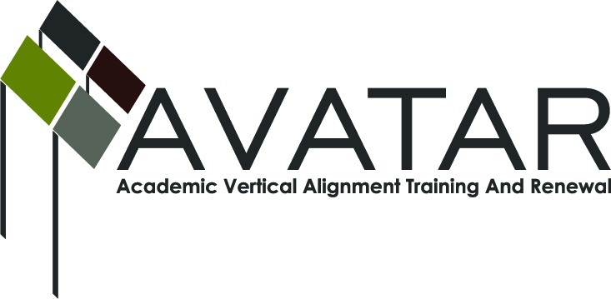
AVATAR Regional Partnership: Region 10
Meeting/Session Documentation Form

Form should be completed after the each meeting and given to the Regional AVATAR Coordinator/Facilitator
Meeting: | Region 10 AVATAR Team
Meeting Purpose: | Year End Summary/Reflections
Date: | May 20, 2014 | Start Time: | 5:30 PM | End Time: | 7:30 PM
Meeting Coordinator/ Facilitator: | Chris Kanouse | Location: |  | A Bldg. Room A203
Meeting Recorder: | Marilyn Lynch | Meeting Timekeeper: |  | Marilyn Lynch

Time | Topic | Format | Discussion Leader | Desired Outcome
5:30 PM | Introductions/Reflections/Invitation | Feedback | Chris Kanouse  Mary Harris | Reconnection to 3 year purpose  AVATAR Reader’s Theatre
6:00 PM | AVATAR Final Summaries PPt and Discussion of Conley’s Key Principles | Presentation | Chris Kanouse | Review of outcomes met
6:45 PM | Written Reflection and Goal Setting | Work Group | Chris Kanouse | Recommitment to continued action steps
7:15 PM | HB 5 and College Prep Course Dev. | Presentation | Chris Kanouse | Update on additional collaborations
Agenda Format Key: P = Presentation, F = Feedback, D = Decision-Making, W = Work Group, O = Other, with explanation

May 20, 2014 AVATAR Meeting Minutes

Action Item | Person Responsible | Due Date
Each group member submitted a long term goal he/she will continue to address | Individual commitments by each attendee | 2014-2015 focus
Notes
Group members each shared professional achievements related to AVATAR activities accomplished throughout this year. The AVATAR Final Summary PowerPoint highlighted original and current data of the secondary and postsecondary project partners programs. The Region 10 process for addressing HB 5 was reviewed and the draft of the math college preparatory course that has been created was distributed for review. Group members each received copies of Conley’s Key Principles of CCR, AVATAR Comparison of Secondary and Postsecondary Chemistry, AVATAR Questions for DISD, HB 5 Side by Side Preparatory Course Summary, Draft of College Prep course for Mathematics, MOU for Region 10 College Prep. Course Collaborative, SFA STEPS Resource. Each group member completed and submitted a written 2014 AVATAR Reflections.
Discoveries: Many students starting college are not equipped to adequately manage college level academic and life expectations. The importance of high school Algebra II math ability and success in college math. AVATAR has continued to have effect and impact in my school community across these last three years. Knowing each other’s worlds well enough to assist each other takes lots of time and strong relationships in order to achieve new outcomes with students. The responsibility of early college, post-secondary institutions and teachers is really to work with feeder schools into high schools as early as possible to ensure college readiness standards are addressed and that everyone is bridging the academic and personal skills gaps to ensure college success.

Changes made to better support students/efforts: Incorporated more technologies (such as social media, online learning goals) in my classroom. Teaching college success skills in the classroom. Less is more…shorter, more concise lessons rather than broad, more shallow lessons. Developed and incorporated college skills into our two entry-level math courses with measureable positive results. Working with principals in school leadership network to focus on college readiness standards. Sought additional pathways to communicate college readiness concerns.

Long term goals you will continue to address: Keep lines of communication open with current AVATAR group members and with DISD administration to support continued P-16 alignment; Continue to “meet” students where they are and provide structural learning support to help them succeed; Increase collaboration between principals and teachers in middle school, high school, and college to ensure alignment and synchronize educational standards; Determine ways to address the most important concepts in the limited time frames given; Building better relationships with colleges and promoting AVATAR in our school community;

Additional comments: I was impressed with that the actual success of students in college was better predicted by transcripts than entrance tests.

May 20, 2014 Meeting Participant List

Name | Title | Organization/Institution | Sign In
Aamir Ashiqali | Leadership Consultant |  | AA
Susan Freid | Professor Math | Brookhaven College | SF
Mary Harris | Research Faculty | Univ. of North Texas | MH
Linda Johnson | Executive Director College and Career Readiness | Dallas ISD | LJ
Chris Kanouse | Program Director for School Support and Educator Certification | Region 10 ESC | CK
Marilyn Lynch | Associate Vice President, Career and Program Resources | Brookhaven College | ML
Diana Mason | Associate Professor/Chemistry (retired) | Univ. of North Texas | DM
Maria Ona | Math Teacher | Dallas ISD | Absent
Czarina Reyes | Professor/Math | Brookhaven College | Absent
Doris Rousey | Executive Dean of Science and Math | Brookhaven College | Absent
Mary Ann Teel | Lecturer/Math, Assistant Dept. Chair | Univ. of North Texas | MT
Rachmad Tjachyadi | Chemistry Teacher | Dallas ISD | RT

