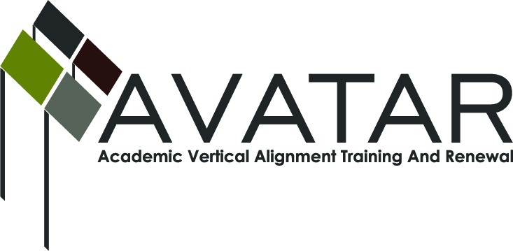
AVATAR Partnership Region: 2
Meeting/Session Documentation Form

Form should be completed after each meeting and given to the Regional AVATAR Coordinator/Facilitator
Meeting: | AVATAR Team Meeting
Meeting Purpose: | Information Meeting
Date: | August 13, 2015 | Start Time: | 3:00 p.m. | End Time: | 4:35 p.m.
Meeting Coordinator/ Facilitator: | Janet M. Cunningham | Location: |  | NW Center for Advanced Studies
Meeting Recorder: | Janet M. Cunningham | Meeting Timekeeper: |  | Connie Nowell

Time | Topic | Format | Discussion Leader | Desired Outcome
3:00 | Welcome/Introductions | Discussion | Janet Cunningham
3:10 | Discussion Items | Discussion | Janet Cunningham
4:15 | Other Concerns | Discussion | Janet Cunningham
4:25 | Plans for Next Meeting |  | Janet Cunningham | Meeting date set.
Agenda Format Key: P = Presentation, F = Feedback, D = Decision-Making, W = Work Group, O = Other, with explanation

AVATAR Meeting Minutes

Action Item | Person Responsible | Due Date
Welcome: Dr. Cunningham welcomed members and asked for introductions.  Discussion Items:  - Explanation of AVATAR. Dr. Cunningham gave a brief explanation of AVATAR and its goals.  - Explanation of English HB5 Team Professional Development. Susan Murphy led this general discussion. All members participated. The requirement for professional development is being requested. On-line training is available.  - College Preparatory Assessment Results. No results have been received from school districts.  - Region 2. General discussion of where we are as a region, how to encourage districts to sign the MOU, number of districts who have signed, the possibility of district students not obtaining IHE credit if that district has not signed MOU, how to obtain last year’s test results, etc.  - Region 1 Partnership. Collaboration between Regions 1 and 2 that students from each district will be given credit by the IHEs in the other district for the course.  - How are districts providing course credit? Impact on RHSP/DAP. The course can be used as advanced math or English on the foundation plan, but not on the advanced or recommended plan.  - College Admittance for CPC students – TSI or NCBO. If a student comes to the IHE with a certificate of having passed the class, the IHE is admitting that student as TSI exempt from developmental math. The certificate must contain the correct PEIMS code.  - Funding/Action Plan for 2015-16. We will be involving workforce in this year’s plan. We will also be hosting the math symposium again this year, as well as the exploring endorsements conference. Dr. Cunningham reported on the externship program.  Other Concerns: The most important need is last year’s test results, to include how many students took the course, which districts offered the course, etc. Dr. Cunningham discussed the possibility of hiring an intern to obtain these results.  Plans for Next Meeting: A meeting has been set for Thursday, September 17, at 3:00 p.m. at the Northwest Center for Advanced Studies. Dr. Cunningham informed members of the $25/meeting stipend. | Dr. Cunningham and Melissa Morin will follow up on MOU issues before next meeting. | September 17, 2015
Notes

Meeting Participant List

Name | Title | Organization/Institution
Dr. Janet M. Cunningham | Executive Director | E2E Partners (P-16 Council)
Roxanne Reninger | Dean of Instruction | Gregory-Portland High School
Jose Guerra | Coordinator – Instructor Math | Texas A&M University-Kingsville
Erica Bertero | Coordinator-Dev Ed/English Dept | Del Mar College
Dr. Paula Kenny-Wallace | Exec Dir/Institutional Effectiveness | Coastal Bend College
Sandra Valerio | Asst. Professor/English | Del Mar College
Veronica Gutierrez | Curriculum Director | Odem-Edroy ISD
Susan Murphy | Assoc. Professor/English | Texas A&M University-Corpus Christi
Melissa Morin | HR Director | ESC-2
Patricia Dominguez | DMC Early College Director | Del Mar College
Tammy Donaldson | Instructor of Reading | Del Mar College
Laura Knippers | Admissions | Texas A&M University-Kingsville
Melana Silva | Curriculum Coordinator | Calallen ISD
Jennifer Minke | Interim Director of Admissions | Texas A&M University-Kingsville
George Tintera | Chair Math | Texas A&M University-Corpus Christi
Ping Tintera | Assist. Professor Math | Texas A&M University-Corpus Christi

