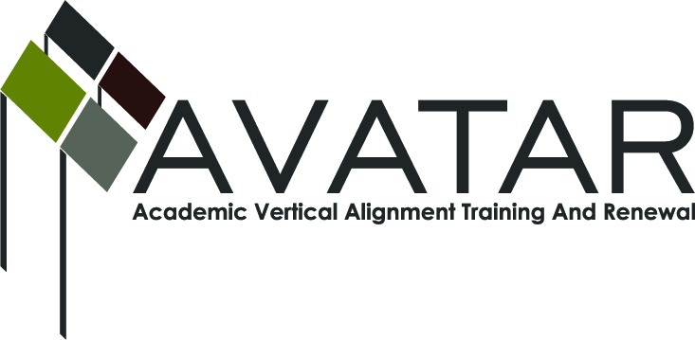
AVATAR Partnership Region: 2
Meeting/Session Documentation Form

Form should be completed after each meeting and given to the Regional AVATAR Coordinator/Facilitator
Meeting: | AVATAR Team Meeting
Meeting Purpose: | Information Meeting
Date: | October 19, 2015 | Start Time: | 3:00 p.m. | End Time: | 4:00 p.m.
Meeting Coordinator/ Facilitator: | Janet M. Cunningham | Location: |  | NW Center for Advanced Studies
Meeting Recorder: | Janet M. Cunningham | Meeting Timekeeper: |  | Connie Nowell

Time | Topic | Format | Discussion Leader | Desired Outcome
3:05 | Welcome | Discussion | Janet Cunningham
3:10 | 2015-16 Goals | Discussion | Janet Cunningham
3:15 | Discussion Items | Discussion | Janet Cunningham
3:50 | Other Concerns | Discussion | Janet Cunningham
3:55 | Plans for Next Meeting |  | Janet Cunningham | Meeting date set.

AVATAR Meeting Minutes

Action Item | Person Responsible | Due Date
Welcome: Dr. Cunningham welcomed members.  Goals: Dr. Cunningham presented the Group’s 2015-16 goals for review and discussion.  Discussion Items:  - ESC Summit. Report given from members who attended and discussion of the summit’s objectives. Participants at summit asked for more communication of events, more information concerning CPC. What should AVATAR’s role and responsibilities be this year concerning getting information to the districts; what is ESC’s role?  - Counselor Survey. Member with results did not attend.  - ELA Training and course. No report.  - College Prep Assessment (fall semester exam). Members will work to produce this fall’s exam.  - Partnership with Region 1. The MOU has been signed by all IHEs. Waiting on districts’ signatures.  - ELA/Math Symposium. Date has tentatively been set for January 21, 2016.  Other Concerns: Discussion of possibility of pairing CPC with another math so that students are able to stay on the recommended plan.  Plans for Next Meeting: A meeting has been set for Monday, November 16, at 3:00 p.m. at Calallen Charter High School. | Dr. Paula Kenney-Wallace will begin work on this project. | November 16, 2015
Notes

Meeting Participant List

Name | Title | Organization/Institution
Dr. Janet M. Cunningham | Executive Director | E2E Partners (P-16 Council)
Dr. Paula Kenny-Wallace | Exec Dir/Institutional Effectiveness | Coastal Bend College
Bethany Goralczyk | Asst Instructor, Math Learning Ctr | Del Mar College
Veronica Gutierrez | Curriculum Director | Odem Edroy ISD

