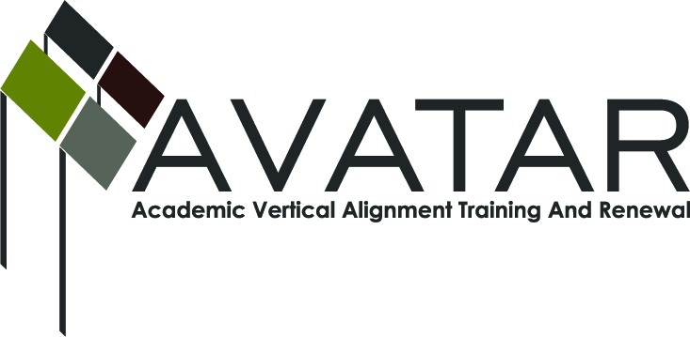
AVATAR Partnership Region: 2
Meeting/Session Documentation Form

Form should be completed after each meeting and given to the Regional AVATAR Coordinator/Facilitator
Meeting: | ELAR/Math AVATAR Team Meeting
Meeting Purpose: | Information Meeting
Date: | November 16, 2015 | Start Time: | 3:00 p.m. | End Time: | 4:30 p.m.
Meeting Coordinator/ Facilitator: | Janet M. Cunningham | Location: |  | Calallen Charter High School
Meeting Recorder: | Janet M. Cunningham | Meeting Timekeeper: |  | Janet M. Cunningham

Time | Topic | Format | Discussion Leader | Desired Outcome
3:00 | Welcome | Discussion | Janet Cunningham
3:10 | Goals for 2015-16 | Discussion | Janet Cunningham
3:15 | Discussion Items | Discussion | Team Members
4:20 | Stipends | Discussion | Janet Cunningham
4:30 | Plans for Next Meeting |  | Janet Cunningham | Meeting date set.

AVATAR Meeting Minutes

Action Item | Person Responsible | Due Date
Welcome: Dr. Cunningham welcomed members.  Goals: Dr. Cunningham presented the Group’s 2015-16 goals for review and discussion.  Discussion Items:  - College Prep Course (CPC). Major discussion on all aspects of the course, to include counselor survey results; implementation of a CPC advisory council, including date of meeting, roles and responsibilities of members, representatives from IHEs, ESC, superintendents, counselors, teachers, TSI coordinators; a timeline of events, CPC webpage suggestions; review of MOU for possible changes; college readiness designation for ELAR/math and procedures; ELA training and course updates; math training and course updates.  - ELA/Math Symposium. Postponed to a later date.  - College Preparatory Mathematics Assessment (fall semester exam). To be distributed for suggestions.  Stipends: To be distributed in December.  Plans for Next Meeting: A meeting has been set for Wednesday, December 2, at 3:00 p.m. at Calallen Charter High School. | All members.  Dr. Paula Kenney-Wallace will send to math team for suggestions.  Dr. Cunningham.
Notes

Meeting Participant List

Name | Title | Organization/Institution
Dr. Janet M. Cunningham | Executive Director | E2E Partners (P-16 Council)
Dr. Paula Kenny-Wallace | Exec Dir/Institutional Effectiveness | Coastal Bend College
Bethany Goralczyk | Asst. Instructor, Math Learning Ctr | Del Mar College
Veronica Gutierrez | Curriculum Director | Odem Edroy ISD
Polly Allred | Math Instructor | Texas A&M University-Kingsville
Sandra Valerio | Asst. English Professor | Del Mar College
Tammy Donaldson | Instructor of Reading | Del Mar College
Elsa Brown | Math Instructor | C Math Is Easy
Steven Mendoza | Math Curriculum Specialist | ESC2
Susan Murphy | Assoc. English Professor | Texas A&M University-Corpus Christi
Shere Salinas | Secondary Math Specialist | CCISD
Jody Briones | Assoc. English Professor | Texas A&M University-Kingsville
Laura Knippers | Admissions | Texas A&M University-Kingsville
Michael Holland | Teacher | Banquete ISD

