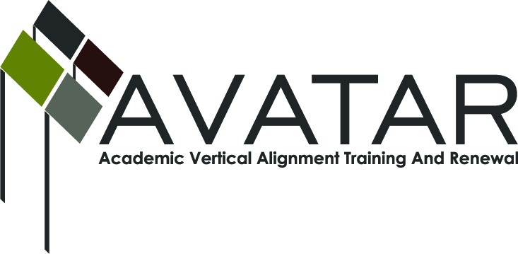
AVATAR Partnership Region: 2
Meeting/Session Documentation Form

Form should be completed after each meeting and given to the Regional AVATAR Coordinator/Facilitator
Meeting: | AVATAR Team Meeting
Meeting Purpose: | Information Meeting
Date: | December 2, 2015 | Start Time: | 3:00 p.m. | End Time: | 4:00 p.m.
Meeting Coordinator/ Facilitator: | Janet M. Cunningham | Location: |  | Northwest Center for Advanced Studies
Meeting Recorder: | Janet M. Cunningham | Meeting Timekeeper: |  | Connie Nowell

Time | Topic | Format | Discussion Leader | Desired Outcome
3:00 | Welcome | Discussion | Janet Cunningham
3:05 | Discuss College Preparatory Course | Discussion | Janet Cunningham | Final agenda for meeting
4:35 | Stipends | Discussion | Janet Cunningham
4:36 | College Prep Math Assessment | Discussion | Janet Cunningham
4:37 | Plans for Next Meeting |  | Janet Cunningham | Meeting date set.

AVATAR Meeting Minutes

Action Item | Person Responsible | Due Date
Welcome: Dr. Cunningham welcomed members.  Goals: Dr. Cunningham presented the Group’s 2015-16 goals for review and discussion.  Discuss College Preparatory Course (CPC):  - Counselor survey results. Sandra Valerio, Del Mar College, presented the results of the counselor survey to members. The survey covered admissions, testing, etc.  - CPC Advisory Council. Members discussed date, attendees, and agenda. Dr. Cunningham reported on confirmed attendees and asked for additions. Discussion regarding what is needed to make the meeting a success and what outcome is expected. The MOU and its addendum were discussed, as well as partnership with Region 1. Roles and responsibilities of the council, procedures, timeline, and CPC webpage were also discussed.  - Tentative Timeline. A timeline of events for the council was presented and discussed.  - ELA/Math training and course updates.  Stipends: Distributed.  College Preparatory Mathematics Assessment (fall semester exam). Math members met briefly to discuss.  Plans for Next Meeting: A meeting has been set for Monday, January 11, at 4:00 p.m. at Northwest Center for Advanced Study. | All members.  Dr. Cunningham
Notes

Meeting Participant List

Name | Title | Organization/Institution
Dr. Janet M. Cunningham | Executive Director | E2E Partners (P-16 Council)
Shelly D. Key |  | TAMUK
Polly Allred | Math Instructor | Texas A&M University-Kingsville
Sandra Valerio | Asst. English Professor | Del Mar College
Tammy Donaldson | Instructor of Reading | Del Mar College
Elsa Brown | Math Instructor | C Math Is Easy
Susan Murphy | Assoc. English Professor | Texas A&M University-Corpus Christi
Shere Salinas | Secondary Math Specialist | CCISD
Michael Holland | Teacher | Banquete ISD
Melana Silva | Curriculum Director | Calallen ISD

