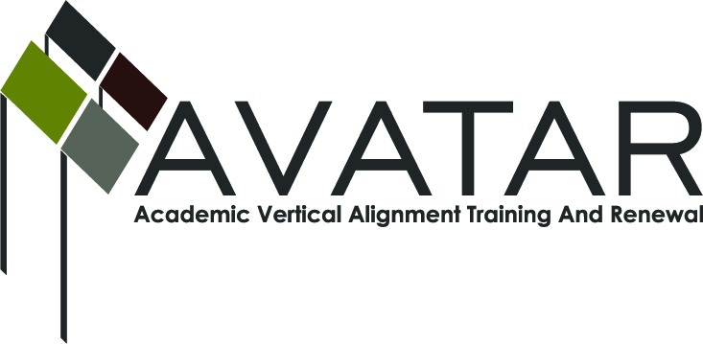
AVATAR Partnership Region: 2
Meeting/Session Documentation Form

Form should be completed after each meeting and given to the Regional AVATAR Coordinator/Facilitator
Meeting: | AVATAR Team Meeting
Meeting Purpose: | Focus of Work; Symposium Planning
Date: | November 18, 2013 | Start Time: | 3:10 p.m. | End Time: | 4:30 p.m.
Meeting Coordinator/ Facilitator: | Janet M. Cunningham | Location: |  | STAR Annex
Meeting Recorder: | Janet M. Cunningham | Meeting Timekeeper: |  | Connie Nowell

Time | Topic | Format | Discussion Leader | Desired Outcome
3:10 p.m. | Welcome | Discussion | Janet Cunningham
3:12 p.m. | Discussion Items | Discussion | Janet Cunningham
4:05 p.m. | Mathematics Symposium | Discussion | Janet Cunningham | Organize sessions/presenters
4:23 p.m. | Next Meeting | Discussion | Janet Cunningham | Set date
Agenda Format Key: P = Presentation, F = Feedback, D = Decision-Making, W = Work Group, O = Other, with explanation
AVATAR Meeting Minutes

Action Item | Person Responsible | Due Date
Discussion Items:  - District and Region Data Reports  - Legislative/Curriculum Updates  - State AVATAR Meeting  - Developmental course/TSI Assessment  Professor Paul Johnson presented Del Mar College’s demographic information to the group. His report was followed by reports from Dr. Silva, Calallen High School; Ms. Palmero, Odem-Edroy ISD; and Carlos Guerrero, Robstown High School. All reports were reviewed and discussed. The statistics regarding students needing math developmental education were not good.  There seems to be no substantive new information regarding curriculum updates. The State Board of Education meets this week and will make their final determination in January 2014. Dr. Silva will be testifying before the Board and will give a report at the next meeting.  Melissa Morin will provide her notes from the State AVATAR meeting held by conference call to members.  There followed a discussion of developmental courses and the new TSI assessment. It was noted that the higher education institutions have an opportunity to work with high schools to develop high school courses which will better prepare those students to take the TSI exam starting with the 2014-15 school year. The group needs to think of ways to assist in this preparation and bring those ideas to the next meeting. | Dr. Cunningham will compile all data received for next meeting  Dr. Silva  Melissa Morin  Members to offer ideas on ways to assist in this process. | December 16, 2013
Mathematics Symposium - February 20 (new date) at the ESC. Dr. Cunningham presented a tentative schedule of events and possible session topics. The sessions were set to include an update on the new TSI assessment, plans for developmental education, the impact of HB5 on high schools and higher ed, and breakout sessions on what to do after CSCOPE and a discussion of college pathways. | Members should bring suggestions for presenters to cover these topics to the next meeting. | December 16
Next meeting – Monday, December 16, at 3:10 p.m., STAR Annex, 4201 Calallen Dr., Room D-9. | Dr. Janet Cunningham
Notes

Meeting Participant List

Name | Title | Organization/Institution
Dr. Melana Silva | Curriculum Specialist | Calallen ISD
George Tintera | Associate Professor | Texas A&M University-CC
L. Gay Palmero | Curriculum Specialist | Odem-Edroy ISD
Carlos Guerrero | Instructional Coach | Robstown High School
Paul Johnson | Associate Professor | Del Mar College
Melissa Morin | Research & Planning | ESC-2
Dr. Janet M. Cunningham | Executive Director | Education to Employment Partners (P-16 Council)

