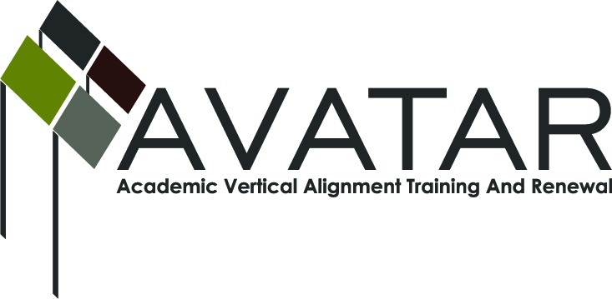
AVATAR Partnership Region: _All_
Meeting/Session Documentation Form

Form should be completed after each meeting and given to the Regional AVATAR Coordinator/Facilitator
Meeting: | Facilitator/Coordinator Conference Call
Meeting Purpose: | Celebrate each Region’s Success; Clarify Next Steps; and Answer Any Questions
Date: | October 11th, 2012 | Start Time: | 9:30 am | End Time: | 10:40 am
Meeting Coordinator/ Facilitator: | Jean Keller | Location: |  | Conference Call
Meeting Recorder: | Kerry Quinn | Meeting Timekeeper: |  | Jean Keller

Time | Topic | Format | Discussion Leader | Desired Outcome
9:30 | Check-In: Success, Lessons Learned, and Help Needed | F & O  (Discussion) | Jean Keller | Regional Facilitators/Coordinators are able to share progresses and learn from each other. AVATAR Staff Members are able to assess where help is most needed.
10:15 | Next Steps: Modules, Action Plans, Use of the Website, and Expenditures | F & O  (Discussion) | Jean Keller | Regional Facilitators/Coordinators are made aware of upcoming deliverables and the availability of the website and modules.
10:25 | Questions/Concerns | F | Jean Keller | Regional Facilitators/Coordinators are able to ask questions regarding region-specific concerns or overarching questions
Agenda Format Key: P = Presentation, F = Feedback, D = Decision-Making, W = Work Group, O = Other, with explanation

AVATAR Meeting Minutes

Action Item | Person Responsible | Due Date
Regional Facilitators/Coordinators will advance in their next steps to create (or expand) team member groups, share updates to regional group lists, provide minutes for all AVATAR meetings, produce regional Action Plans, fine-tune Data PowerPoints to tell a story, and hold meeting/trainings with team members  (Meeting Session Documentation Summary and Regional Action Plan format available at: http://www.ntp16.notlb.com/avatar/files/training/forms) | All Facilitators/Coordinators, with assistance from their partners | Ongoing  Minutes due for 1st meeting: September 24, 2012  Minutes due for Team Member Training: October 29, 2012  Action Plan due: October 29, 2012  (see Due Dates and Deliverables document available at: http://www.ntp16.notlb.com/avatar/files/training/tot-documents)
Regional Facilitators/Coordinators will participate in follow-up calls with AVATAR Co-Directors | Kerry will call last week in October to arrange a conference call | Before November 30, 2012
Completed Modules 1, 2, and 3 | AVATAR Staff | October 22, 2012
Notes
- Welcome
  - Jean facilitated a “roll call” of all participating on the conference call
  - Jean welcomed all participants and thanked them for their time and commitment
- Check-In: Successes, Lessons Learned, and Help Needed
  - Region 2:
    - Partners are working together well
    - Beginning critical/enlightening conversations
    - Concerned about how to implement the work being done on the local college campuses
    - The Data PowerPoint was really helpful because it makes the challenges and struggles of unprepared students clear
  - Region 6:
    - Focused on finding the right people for Region 6.
    - Inviting teachers to join as team members
    - Planning to meet on November 8th
    - Experienced the value of the critical conversations when a college professor and high school teacher exchanged syllabi and were able to recognize the incompatibility between the two
  - Region 12:
    - With the support of the P-20 council, working to include one English teacher from each of the 10 high schools and the English faculty from 4 different IHEs
    - Working to facilitate a faculty exchange between McLennan Community College and local high school teachers
    - Planning to expand to mathematics and science in 2013-2015

  - Region 13:
    - Last week at the Curriculum Council meeting, aligned physics student expectations
    - Focusing on English with an emphasis on writing
    - Seeking a way to chronicle the project in a meaningful way
    - Solidified Austin Community College and Anderson High School partnership
    - Working to strengthen 4-year partnership
  - Region 14:
    - Next meeting is October 17th
    - Scheduling a time to speak at the next P-16 meeting
  - Region 15:
    - Agreed to focus on English this year and mathematics in 2013-2014, with support from the San Angelo ISD superintendent
    - Meeting today with partners 10/11 and will finalize team members
  - Region 16:
    - Formed relationships with a 4-year IHE, three 2-year IHE, and four high schools
    - Just waiting to receive confirmation and specific names of team members from the institutions
    - Enjoying the process of coming together
    - Agreed to post Data PowerPoint when receives partners’ confirmation
  - Region 20:
    - There is a community buzz about college algebra
    - Planning a College and Career Readiness Forum
    - ELA teachers and faculty are staying on this year and will be the region’s focus 2013-2014
    - Appreciates the witnessed respect and quality in partner meetings
    - Reworking the Data PowerPoint to tell a story
    - Will be studying the data results from the ACCUPLACER and other exams at next meeting
- Next Steps: Modules, Action Plans, Use of the Website, Expenditures
  - Modules:
    - Please just use what is relevant to your region to support the topics of critical conversations (Critical Conversations Pyramid)
    - We are working to refine these; will be posted by 10/22
    - There are many resources available; please check the AVATAR website’s resources
    - The critical conversation pyramid is fluid, your group will move up and down to ensure common understanding
  - Action Plans:
    - There were no questions; feel free to email any of the staff with questions or concerns
    - These are due October 29th
  - Website:
    - Your regional folders will contain your Minutes, Action Plans, and PowerPoints and any other material you wish
    - Please utilize this resource as a one place that your partners can go for any information needed
    - Please give us any feedback you have on the website
  - Expenditures
    - We will prepare a document for you all to use to summarize your expenses for personnel (stipends, etc.), travel, meeting planning and supplies
    - It will be posted at http://www.ntp16.notlb.com/avatar/files/training/forms

- Questions/Concerns:
  - How can use the money for our teachers/professors?
    - Travel reimbursement
    - Payment to the districts for substitutes
    - Small stipends to the individuals
  - Can we use the money to provide snacks, drinks, and other refreshments?
    - Yes, you can use the money for food for your meetings
    - We encourage you to provide something for them to eat and drink at all meetings
  - How can you incorporate online in your meetings?
    - Ed Vara: we prepared for our meetings before hand by emailing and uploading materials online. This allowed each individual to read materials on their own time. Meetings were quick and powerful by blending face-to-face with electronic preparation.
- Conclusion
  - Jean: Thank you all for your work to benefit students to be college and career readied
  - Priscilla: Thanks to all participants. The P-16 Institute is in February 2013 and I would like to have an AVATAR presentation.

Meeting Participant List

Name | Title | Organization/Institution
Janet Cunningham | Facilitator/Coordinator | Region 2, Citizens for Educational Excellence
Julia Woods  (substitute for Joe Martin) | School Improvement/Certification Specialist | Region 6, ESC
Kathy Harvey | Facilitator/Coordinator | Region 9, ESC
Kathy Wright-Chapman | Facilitator/Coordinator | Region 11A and 11B, ESC
Christine Holecek | Facilitator/Coordinator | Region 12, ESC
Ed Vara | Facilitator/Coordinator | Region 13, ESC
Misty Bloomingdale  (substitute for Christy Barnett) | Secretary to Christy Barnett | Region 14, ESC
Karan Duwe | Facilitator/Coordinator | Region 15, ESC
Robin Adkins | Facilitator/Coordinator | Region 16, ESC
Ravae Shaeffer | Facilitator/Coordinator | Region 20, ESC
Priscilla Martinez | Program Director, Success Initiatives | THECB
Sharon Smith | Research Assistant, External Evaluator | Shore Research
Jean Keller | AVATAR Co-Director | AVATAR, University of North Texas
Mary Harris | AVATAR Co-Director | AVATAR, University of North Texas
Kerry Quinn | Graduate Assistant | AVATAR, University of North Texas
(Unable to attend: Chris Kanouse, Laura Saenz, Jane Silvey)

