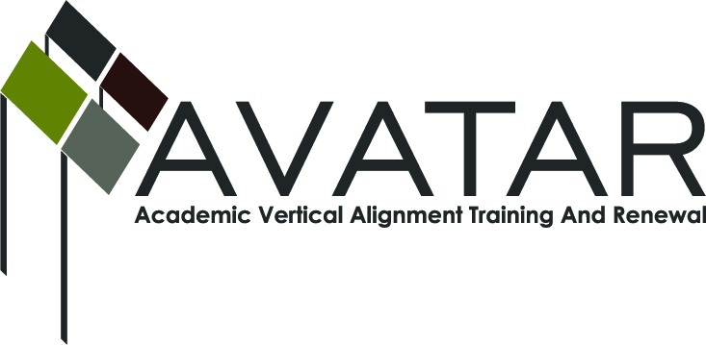
AVATAR Partnership Region: 16
Meeting/Session Documentation Form

Form should be completed after each meeting and given to the Regional AVATAR Coordinator/Facilitator
Meeting: | English Language Arts Vertical Alignment Team
Meeting Purpose: | Review fall ELA college prep course information.
Date: | Wed., Feb. 4, 2015 | Start Time: | 12:30 pm | End Time: | 1:30 pm
Meeting Coordinator/ Facilitator: | Robin Adkins | Location: |  | Red River Room, Region 16 ESC
Meeting Recorder: | RA | Meeting Timekeeper: |  | RA

Time | Topic | Format | Discussion Leader | Desired Outcome
12:30 pm | 1. Introductions. | P | RA
12:35 | 2. Review grant due dates & deliverables. Review R16 survey responses. | P/F | RA | Understand grant requirements & purposes of VAT. Gain perspective on CPC offerings in the region.
12:55 pm | 3. Review fall ELA CPC offerings:  a. Student data  b. Implications for spring, including possible professional development  c. Unit tests | F/D/W | RA | Consider progress and implications for implementation.
1:30 pm | 4. Adjourn. |  | RA
Agenda Format Key: P = Presentation, F = Feedback, D = Decision-Making, W = Work Group, O = Other, with explanation
AVATAR Meeting Minutes (See “Notes” page for more info)

Action Item (numbered items below correspond to agenda items above) |  | Person Responsible | Due Date
3. Check that enrolling WT students who passed CPC(s) in HS and then passed AC’s freshmen level ELA/math are considered “TSI compliant” for WT. |  | WS
3. Plan/schedule CPC overviews by AC & AISD staff for regional ISDs this spring. |  | RA | Schedule to occure before ISDs complete master schedules for `15-16.
3. Complete/submit survey using feedback from this meeting. |  | RA | Feb. 15, 2015
Notes
Discussions revolved around agenda items, the above action items, and the following notes.

--Robin Adkins reviewed the grant’s due dates & deliverables document and purposes of the VAT. Responses from survey of Region 16 ISDs having MOUs with AC & FPC were reviewed.
--Jennifer Wilkerson said that AISD students were placed into ELA CPC based upon TSI score. Parents could opt-out.
--Reviewed first semester grades from each AISD HS campus provided by Jennifer. Wade Shaffer commented that A-F grade distributions were classic grade distributions for freshmen college students.
--Jennifer said they will track success in freshmen level English of the AISD students who attend AC. Wade commented that if we have the social security numbers of students who took the CPC, their success levels can be tracked at any IHE in the state through the “Texas Clearinghouse.” Jennifer will check into the possibility of students’ parents allowing the tracking via SS #s.
--Jennifer said at least two reps from each AISD campus will meet with AC staff for grade-norming of the ELA CPC as well as other review.
--Adkins asked question from the survey that will be submitted by Feb. 15: “How does your partnership see College Preparatory Courses in relationship to other elements of HB5 such as endorsements, local Career and Technical Education (CTE) courses, and other aspects of college or career readiness?”
Responses: For Foundation Program students, CPC can count as fourth credit of ELA. STEM students might not want to take British Literature their senior year, but can take the CPC which can help in technical writing skills. Same with fine arts students. The CPC gives students options most appropriate to their Foundation plans and helps them more with career readiness than typical fourth-year ELA. It also gets lower achieving students “ahead of the game” by not having to take developmental education classes in college.

Meeting Participant List

Name | Title | Organization/Institution
Jennifer Wilkerson | Core Curriculum Specialist, ELAR 6-12 | Amarillo ISD
Frank Sobey | Asst. Prof./Dept. Chair of English, Humanities, and Languages | Amarillo College
Wade Shaffer | Provost/VP for Academic Affairs | West Texas A&M University
Robin Adkins | P-16 Specialist/Team Facilitator | Region 16 ESC

