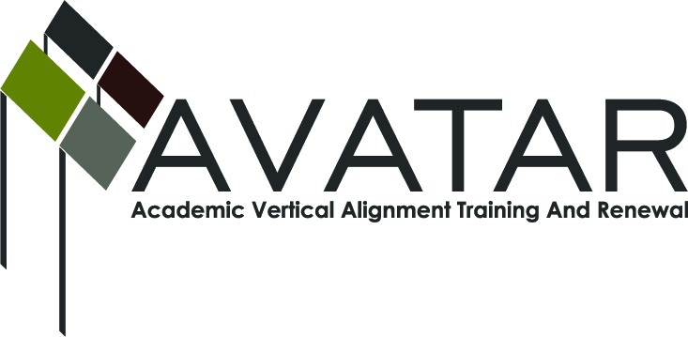
AVATAR Partnership Region: 16
Meeting/Session Documentation Form

Form should be completed after each meeting and given to the Regional AVATAR Coordinator/Facilitator
Meeting: | AVATAR Team
Meeting Purpose: | Plan for 7/10 & 7/29 presentations.
Date: | June 25, 2014 | Start Time: | 1:00 pm | End Time: | 3:00 pm
Meeting Coordinator/ Facilitator: | Robin Adkins | Location: |  | Computer Services Lab, Region 16 ESC
Meeting Recorder: | RA | Meeting Timekeeper: |  | RA

Time | Topic | Format | Discussion Leader | Desired Outcome
1:00 pm | 1. Planning for presentations: July 10 – R16 Math Conf.; July 29 – R16 Instructional Strategies Conf. | W/D | RA | Plan presentations.
2:50 pm | 2. Consider date for meeting before and/or after July 10 presentation, if needed. | F/D | RA | Set next meeting date to finalize presentations and discuss `14-15 projects.
3:00 pm | 3. Adjourn. |  | RA
Agenda Format Key: P = Presentation, F = Feedback, D = Decision-Making, W = Work Group, O = Other, with explanation
AVATAR Meeting Minutes (See “Notes” page for more info)

Action Item (numbered items below correspond to agenda items above) |  | Person Responsible | Due Date
1. Robin send PowerPoint of July 10 presentation to Gregg to post in Dropbox. He will invite presenters to access & view. |  | Robin, Gregg | June 26, 2014
Notes
Discussions revolved around agenda items, the above action items, and the following notes.
Item #1:
--Presenters: July 10 = Beth, Stan, & Robin; July 29 = Beth, Stan, Cathy, & Robin.
--DRAFT OUTLINE FOR PRESENTATIONS at July 10 REGION 16 MATH CONFERENCE, AND JULY 29 REGION 16 INSTRUCTIONAL STRATEGIES CONFERENCE:
“College Readiness: Aligning Algebra II & College Algebra”
Beth Summers, Professor of Math, Frank Phillips College
Stan Maxwell, Math Teacher, West Texas High School
Cathy Coleman, Math Teacher, Amarillo High School
Robin Adkins, P-16 Specialist, Texas Panhandle P-16 Council
1. Recognition of need:
a. Brief overview of statewide and regional AVATAR Project
b. Review of college readiness data
c. Review of numbers of students who enroll in college developmental math, on-level college math, and their outcomes.
2. Establishing relationships between high school and college math instructors: perspectives from members of Region 16’s AVATAR Math Project.
3. Tools, strategies, & resources teachers can use to enhance success of Algebra II students planning to take College Algebra:
a. Student-maintained math journals
b. Characteristics of successful college students
4. Q&A with high school and higher education math instructors.
--Adkins prepare handouts for July 10: Math Concepts, Characteristics of Successful College Students, and journal sample pages.
Meeting Participant List

Name | Title | Organization/Institution
Cathy Coleman | Math Teacher | Amarillo HS
Kim Seward | Math Instructor | West Texas A&M Univ.
Stan Maxwell | Math Teacher | West Texas HS
Robin Adkins | P-16 Specialist/Team Facilitator | Region 16 ESC

