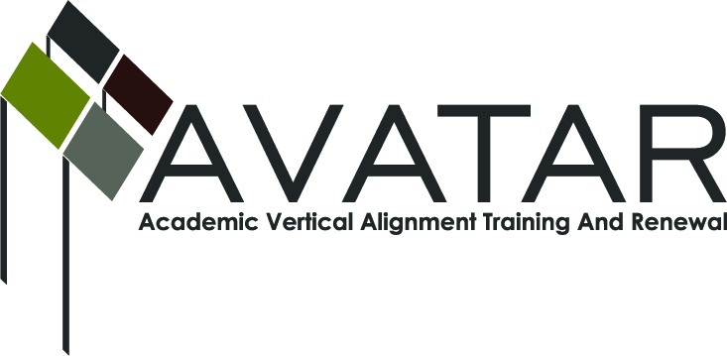
AVATAR Partnership Region: ESC 16
Meeting/Session Documentation Form

Form should be completed after each meeting and given to the Regional AVATAR Coordinator/Facilitator
Meeting: |  | AVATAR Coordinator (Robin Adkins) & Math Team Member (Cheryl Freeman)
Meeting Purpose: |  | Progress Report: `13-14 Activities to-date & Planning
Date: |  | 1-10-14 | Start Time: | 2:50 pm |  |  | End Time: |  | 3:50 pm
Meeting Coordinator/ Facilitator: |  | Robin Adkins | Location: |  |  |  | Canyon High School
Meeting Recorder: |  | RA | Meeting Timekeeper: |  |  |  | RA
Time | Topic |  |  |  | Format | Discussion Leader |  | Desired Outcome
2:50 pm | 1. Discuss activities to-date. |  |  |  | F | RA/CF |  | Gain understanding of work done to-date.
3:20 pm | 2. Discuss next steps. |  |  |  | F | RA/CF |  | Planning for project.
3:50 pm | 3. Adjourn.

Agenda Format Key: P = Presentation, F = Feedback, D = Decision-Making, W = Work Group, O = Other, with explanation

AVATAR Meeting Minutes
Numbered items below correspond to agenda items above.
1. Cheryl teaches upper level classes (dual-credit & AP) so hasn’t implemented journal. Jessica Ray teaches Alg. II, but hasn’t implemented journal. Her students keep a notebook for their own benefit (includes “foldables”). Jessica tells them how to set it up. Students cull out info at beginning of Coll. Alg. to make it more concise. Other reasons for not implementing: -Time contraints; -Not knowing what it should look like; -Thinks kids wouldn’t keep up with it and would require too much teacher effort; -Thinks seniors are set in their ways and wouldn’t want to do it; -Kids would rather look up the information on Khan Academy and on the teacher tutorial site.

2. Cheryl thinks teachers sharing different ideas and techniques to teach the same concept would be valuable. We need to come up with ideas and techniques (e.g., “foldables”) to grab students’ attention and share those ideas with each other.

Meeting Participant List

Name | Title | Organization/Institution
Cheryl Freeman | AVATAR Math Team Member – Math Teacher | Canyon High School
Robin Adkins | AVATAR Coordinator – P-16 Specialist | Region 16 ESC

