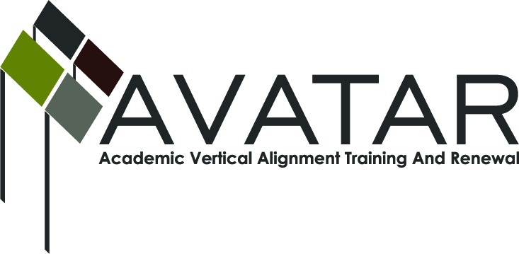
AVATAR Partnership Region: 2
Meeting/Session Documentation Form

Form should be completed after each meeting and given to the Regional AVATAR Coordinator/Facilitator
Meeting: | AVATAR Team Meeting
Meeting Purpose: | Focus of Work
Date: | May 14, 2014 | Start Time: | 4:00 p.m. | End Time: | 6:40
Meeting Coordinator/ Facilitator: | Janet M. Cunningham | Location: |  | STAR Annex
Meeting Recorder: | Janet M. Cunningham | Meeting Timekeeper: |  | Connie Nowell

Time | Topic | Format | Discussion Leader | Desired Outcome
4:05 p.m. | Welcome | Discussion | Janet Cunningham
4:15 | Discussion Items | Discussion | Janet Cunningham | Plan for college preparatory course
6:35 p.m. | Next Meeting | Discussion | Janet Cunningham | Set date
Agenda Format Key: P = Presentation, F = Feedback, D = Decision-Making, W = Work Group, O = Other, with explanation
AVATAR Meeting Minutes

Action Item | Person Responsible | Due Date
Welcome:  Dr. Cunningham welcomed Polly Allred, Texas A&M University-Kingsville, to the group.  Discussion Items:  - MOU for College Preparatory Course  Dr. Cunningham presented a rough draft to the group for discussion and suggestions. The discussion centered mainly around eligible participants, course fees, responsibilities of parties (higher education and school districts), and granting credit. The discussion more specifically included:  • scores needed in order for students to receive high school credit or to be deemed “college ready;”  • what students should be tested on at the end of the course;  • requirements needed before student can enroll in class;  • objectives that need to be taught;  • the end objective of the course;  • how students will receive credit on their college transcript for passing the course;  • whether to have one or two sessions.  - Legislative/Curriculum Updates  Melissa Morin, ESC, gave a report on updates by the TEA.  - Date for Math Symposium  Should be October 28, 29, or 30.  It was decided that the IHE members would meet first to prepare a draft of a syllabus from their perspective regarding developmental education classes and that other members would meet to integrate the IHE information with TSI objectives and college ready information into the IHE syllabus.  The urgency of the need for information to disseminate to the high schools was passed to the group. | All AVATAR members  Dr. Cunningham will incorporate changes discussed and prepare a new draft for review.
Next meeting – Tuesday, May 20, at 4:00 p.m., STAR Annex, 4201 Calallen Dr. | Dr. Janet Cunningham | May 20, 2014
Notes

Meeting Participant List

Name | Title | Organization/Institution
Jake Salcines | Dean of Instruction | West Oso ISD
Dr. Melana Silva | Curriculum Coordinator | Calallen ISD
Dr. Janet M. Cunningham | Executive Director | E2E Partners (P-16 Council)
Paula Kenney-Wallace | Division Chair | Coastal Bend College
Toni Norrell | Math Specialist | ESC-2
Melissa Morin | Research & Planning | ESC-2
Lisa Hernandez | Math Teacher | Odem-Edroy ISD
Polly Allred | Math Instructor | TAMU-Kingsville
Paul Johnson | Math Instructor | Del Mar College
George Tinterra | Associate Professor | TAMU-Corpus Christi

