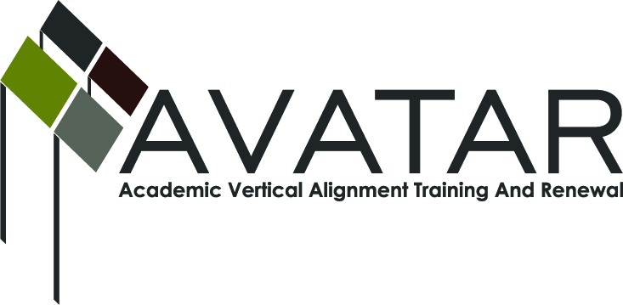
AVATAR Partnership Region: 2
Meeting/Session Documentation Form

Form should be completed after each meeting and given to the Regional AVATAR Coordinator/Facilitator
Meeting: | AVATAR Team Meeting
Meeting Purpose: | Review College Preparatory Course Syllabus
Date: | June 2, 2014 | Start Time: | 3:00 p.m. | End Time: | 5:30 p.m.
Meeting Coordinator/ Facilitator: | Janet M. Cunningham | Location: |  | STAR Annex
Meeting Recorder: | Janet M. Cunningham | Meeting Timekeeper: |  | Connie Nowell

Time | Topic | Format | Discussion Leader | Desired Outcome
3:10 | Discussion Items | Discussion | Janet Cunningham | New draft of course syllabus
Agenda Format Key: P = Presentation, F = Feedback, D = Decision-Making, W = Work Group, O = Other, with explanation
AVATAR Meeting Minutes

Action Item | Person Responsible | Due Date
Discussion Items:  Review of draft of college preparatory course syllabus with a view towards a final draft. All areas were covered, to include:  - Course Description. Concerns included how completion of the course would be noted on a student’s transcript, designation of the length of the course, and how credit would be issued. Also at question was the expiration term of the course.  - Prerequisities. Grade 10 and 11 students may enroll with principal approval.  - Text and Other Supplies. ELAs may use their discretion regarding what materials and technology they will use to teach the course.  - Student Learning Topics and Objectives. Student outcomes listed under each strand were reviewed. Changes and additions were discussed.  - Evaluation and Grade Assignment. How the class would be evaluated and graded was discussed, along with the grading scale and what grade must be attained for a student to be eligible for NCBO and “college-ready.”  - Tentative Course Schedule. A weekly course schedule was discussed. It was decided that the IHEs, with the help of the ELAs, would produce the semester exams which would be graded by the ELAs. | Dr. Cunningham will incorporate changes discussed and prepare a new draft.
Notes

Meeting Participant List

Name | Title | Organization/Institution
Jake Salcines | Dean of Instruction | West Oso ISD
Dr. Janet M. Cunningham | Executive Director | E2E Partners (P-16 Council)
Toni Norrell | Math Specialist | ESC-2
Melissa Morin | Research & Planning | ESC-2
Lisa Hernandez | Math Teacher | Odem-Edroy ISD
Polly Allred | Math Instructor | TAMU-Kingsville
Paul Johnson | Math Instructor | Del Mar College
L. Gay Palmero | Curriculum Specialist | Odem-Edroy ISD
Cindy Funke | Teacher | Odem-Edroy ISD

