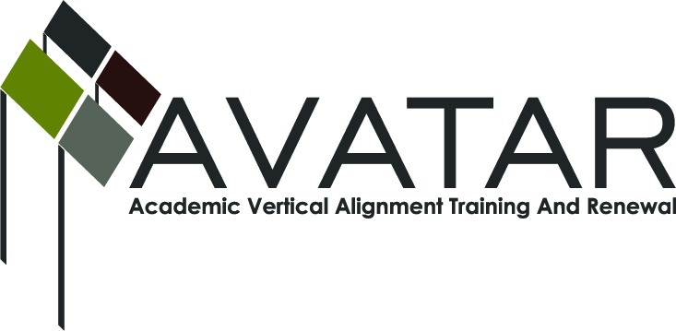
AVATAR Partnership Region: 2
Meeting/Session Documentation Form

Form should be completed after each meeting and given to the Regional AVATAR Coordinator/Facilitator
Meeting: | AVATAR Team Meeting
Meeting Purpose:
Date: | September 8, 2014 | Start Time: | 2:15 p.m. | End Time: | 3:30 p.m.
Meeting Coordinator/ Facilitator: | Janet M. Cunningham | Location: |  | STAR Annex
Meeting Recorder: | Janet M. Cunningham | Meeting Timekeeper: |  | Connie Nowell

Time | Topic | Format | Discussion Leader | Desired Outcome
2:15 | Welcome and Introductions | Discussion | Janet Cunningham | Introduction of this year’s members
2:18 | AVATAR – what it is and what we do | Discussion | Janet Cunningham | Explanation of AVATAR mission
3:10 | Discussion Items | Discussion | Janet Cunningham | Determining where MOUs are in signatory process and college preparatory course is in implementation and work toward finalizing math symposium program
3:26 | Plans for next meeting | Discussion | Janet Cunningham | Set next meeting date
Agenda Format Key: P = Presentation, F = Feedback, D = Decision-Making, W = Work Group, O = Other, with explanation
AVATAR Meeting Minutes

Action Item | Person Responsible | Due Date
Welcome: Dr. Cunningham welcomed all members and had each member introduce himself/herself to the group  AVATAR: Dr. Cunningham explained to the group what AVATAR is and what it does  Discussion Items:  - Status of MOU -- Melissa Morin, ESC2, reported on the status of the MOU and what signatures were still needed. There was discussion of what districts began teaching the course with the fall semester.  - College Preparatory Course – The group discussed the course syllabus, how to get this year’s high school seniors who are not college ready prepared for college, getting students to take the TSI, etc.  - College Preparatory Assessments – Members who have been working on this project were not present at this meeting. The assessments need to be ready to distribute to the districts in November.  - Math Symposium Planning – The symposium is planned for October 29 at the ESC. The group reviewed last year’s topics and suggestions for new topics were discussed.  - Curriculum Updates – Melana Silva will be meeting in Austin this week and will report to the group at the next meeting. | Dr. Cunningham will prepare draft of program for discussion. | October 7, 2014
Notes

Meeting Participant List

Name | Title | Organization/Institution
Dr. Janet M. Cunningham | Executive Director | E2E Partners (P-16 Council)
Melissa Morin | Research & Planning | ESC-2
Lisa Hernandez | Math Teacher | Odem-Edroy ISD
Paul Johnson | Math Instructor | Del Mar College
Cindy Funke | Teacher | Odem-Edroy ISD
Veronica Gutierrez | Math Specialist | Odem-Edroy ISD
Andrea Johnson |  | cMATHisEASY
Elsa Brown |  | cMATHisEASY
Melana Silva | Curriculum Coordinator | Calallen ISD
Joe O. Flores | Math Teacher | Odem-Edroy ISD
Marc Aguilera | Math Specialist | Corpus Christi ISD
Dr. Paula Kenny-Wallace | Math Instructor | Texas A&M University-Corpus Christi

