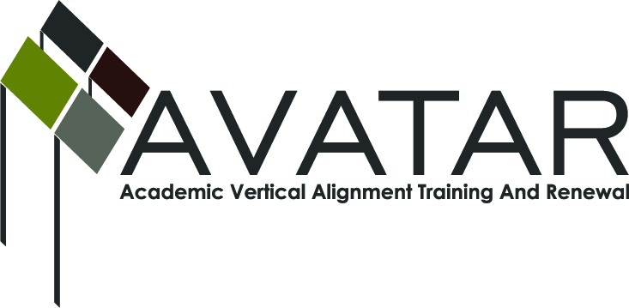
AVATAR Partnership Region: ESC Region 13
Meeting/Session Documentation Form

Form should be completed after each meeting and given to the Regional AVATAR Coordinator/Facilitator
Meeting: | ACC Highland Campus Avatar
Meeting Purpose: | Review action plan and determine content/agenda for training
Date: | 1-22-13 | Start Time: | 5:00 pm | End Time: | 6:40
Meeting Coordinator/ Facilitator: | Jennifer Drumm | Location: |  | Region 13
Meeting Recorder: | Susan Diaz | Meeting Timekeeper: |  | Susan Diaz

Time | Topic | Format | Discussion Leader | Desired Outcome
5:00-5:15 | AVATAR Project Goals | w | Jennifer | Trained new members on project goals.
5:15-5:45 | Review Action Plan | w | Jennifer | Reviewed action and sustainability plan for 2012-2013 . Did not do GenTex presentation. Article is in the revamping stage—will happen on or before June. Video could be taken at the workshop and segmented into 1 hour webinars for people who are unable to attend the f2f workshop to view online. Lessons for soft skills—perhaps craft lessons will replace this? Postpone until further information. Curriculum council updates to be extended to a later date. Wendy shared her document on expectations for Comp I students at ACC. Moriah discussed writing strategies survey as a tool for assessing students’ writing abilities. U of Idaho designing directed self-placement. Creating portfolios that prove students can do the work from the ACC expectations of skills for Comp I. Wendy shared data from Comp I and II and a summary of her work for the article.
5:45 – 6:15 | Workshop; input and potential agenda items | w | Susan | Wendy would present her findings on college readiness. We discussed synthesizing information that is already out there like the Framework in order to further college readiness and STAAR success. Workshop would be f2f before being turned into online components. Each person would take on a one hour piece and the presentation and then we would have a q and a session at the end.  John—non-fiction  Stacia—soft skills  Wendy—findings from article  Susan—EOC  Moriah—Framework, WAW, self-assessment.
Agenda Format Key: P = Presentation, F = Feedback, D = Decision-Making, W = Work Group, O = Other, with explanation

AVATAR Meeting Minutes

Action Item | Person Responsible | Due Date
Sketch out rough draft of workshop—ecampus? | Jenn and Susan
Work on your “part” of the presentation | Moriah, Stacia, Wendy and John
Budget | Jenn
Notes
Meeting Participant List

Name | Title | Organization/Institution
Susan Diaz | Literacy Specialist | ESC Region 13
Wendy Lym | Professor, Associate | Austin Community College
I. Moriah McCracken | Assistant Professor of English Writing & Rhetoric | St. Edwards University
John Villarreal | English IV & English Iv AP/IB Teacher | L.C. Anderson High School
Stacia Bowley | English IV Teacher | L.C. Anderson High School
Jennifer Drumm | Senior Coordinator, Curriculum & Instruction | ESC Region 13

