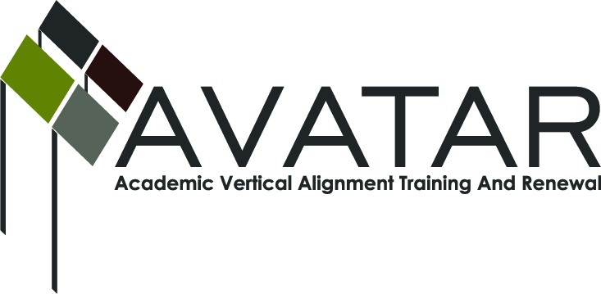
AVATAR Partnership Region: _____15_____________
Meeting/Session Documentation Form

Form should be completed after each meeting and given to the Regional AVATAR Coordinator/Facilitator
Meeting:
Meeting Purpose: | Determine areas of need for vertical alignment and bring more people into the discussion
Date: | 11/8/12 | Start Time: | 3:00 | End Time: | 4:30
Meeting Coordinator/ Facilitator: | Karan Duwe | Location: |  | Region 15 ESC
Meeting Recorder: | Karan Duwe | Meeting Timekeeper: |  | Lorenzo Lasater

Time | Topic | Format | Discussion Leader | Desired Outcome
3:00 | Introduce teachers | F | Lorenzo Lasater | Welcome classroom teachers to the team
3:20 | Background information | F | Lorenzo Lasater | Help teachers understand the background information and our goals
3:45 | Data and Documents  What is “success” and “college ready”  Expectations of 1301 and EOC 3 | Discussion | Lorenzo Lasater  Karan Duwe | Consensus on needs
Agenda Format Key: P = Presentation, F = Feedback, D = Decision-Making, W = Work Group, O = Other, with explanation

AVATAR Meeting Minutes

Action Item | Person Responsible | Due Date
Get state release exams and rubrics for next meeting | Karan Duwe | 12/6
Send link with regional statistics and AVATAR project website to all present | Karan Duwe | 11/14
Invite Middle School teachers to the table | School district personnel | 12/1/12
Notes
Meeting began with introductions for the benefit of Eden and SAISD English teachers followed by a background discussion and recap of last month’s meeting.
Discussion followed:
Ways to talk about the gap between HS and Higher Ed.
How does the state define “success?”
Does Phase 3 of EOC determine college readiness?
EOC Phase 3 students will be more ready for college than TAKS passers.

Discussion about vertical alignments?
Are the expectations the same? Does the State expectation of EOC 3 match the expectations of college freshmen by college professors?
College instructors are concerned that even after the bridge course (developmental) students cannot punctuate.

Who are we going to target in our discussions of alignment?
Dual Credit students? AP students? Regular English 3 and 4 students?
Non passers in general?

There was discussion for college instructors about the complexity of how passing is determined.
HS teachers discussed paying more attention to TEKS than the literature and using passages versus whole novels.
HE instructors wondered if HS teachers needed help grading due to large numbers of students. What about conferencing time? Some schools using Turn It In program to begin the editing process. Schools need labs for students to do their writing. Evening tutorials are available at Central HS, but the regular ed kids don’t often attend.

ASU: What about a shared vocabulary regarding sentences? 4 major sentences. That would be a significant step in the right directions. Do students need to identify parts of speech?

Decision was to meet in February for a 3 hour dinner meeting to finish discussion about vertical alignment. May focus on preparing a one or two page document with a shared vocabulary list and sentence types.

Meeting Participant List

Name | Title | Organization/Institution
Karan Duwe |  | ESC 15
Jean Hase | Teacher | SAISD
Nancy Treadwell | Instructor | Howard College
Misty Killibrugh | Principal | Eden CISD
Lorenzo Lasater | Chair | San Angelo P15 Council
Claudia Becerra | Teacher | SAISD
Rebecca Bunger | Teacher | Eden CISD
John Miazga | Dean | Angelo State University
Lee Ann Byrd | Dean | Howard College
Sue Van Hoozer |  | ESC 15

