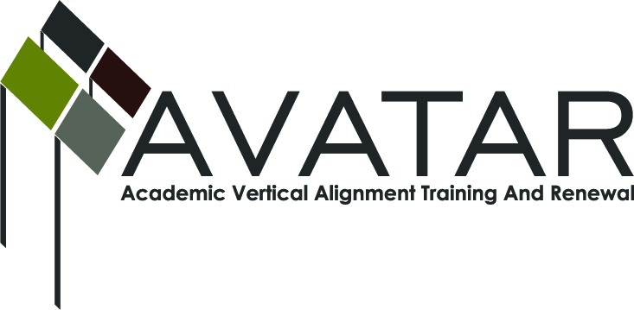
AVATAR Partnership Region: ESC 16
Meeting/Session Documentation Form

Form should be completed after each meeting and given to the Regional AVATAR Coordinator/Facilitator
Meeting: | AVATAR Team Training & Planning
Meeting Purpose: | Team Orientation, Training, & Planning
Date: | 11/16/12 | Start Time: | 8:30 am | End Time: | 11:00 am
Meeting Coordinator/ Facilitator: | Robin Adkins | Location: |  | Region 16 ESC
Meeting Recorder: | RA | Meeting Timekeeper: |  | RA

Time | Topic | Format | Discussion Leader | Desired Outcome
8:30 | Introductions | P | RA | Tammy Nash – Amarillo High School; Cheryl Freeman – Canyon High School; Pam Walker – Borger High School; Beth Summers – Frank Phillips College; Tammy Holmes – Amarillo College; Linda Rowland – Clarendon College; Gregg Lawler – West Texas A&M University; Gwen Hicks – Region 16 ESC; Robin Adkins – Panhandle P-16
8:35 | Review numbers of students who enroll in developmental math classes and college algebra classes, and outcomes (drops, completers, grades earned) compiled by Amarillo HS, Borger HS, and Canyon HS students. | P/F | RA and IHE Partners | Understand the data and determine how to use it for next steps.
9:00 | Review syllabi and Reference Course Profile information for College Algebra classes. | P/F | RA and IHE Partners | Understand the information and determine how to use it for next steps.
9:25 | Review CCRS for math and common math vocabulary developed through P16 work. | P/F | Tammy N. | Understand the information and determine how to use it for next steps.
9:50 | Review resources available at www.sa-ready.org. | P/F | RA | Understand the information and determine how to use it for next steps.
10:15 | Discuss potential professional development opportunities for regional teachers based upon our work. | P/F/D | RA | Begin planning to provide regional teachers with relevant information and tools.
10:40 | Review: Due Dates & Deliverables; Sample Action & Sustainability Plan | P/F/D | RA | Understand expectations; Update Regional Action & Sustainability Plan, if necessary.
10:50 | Next steps & potential meeting dates. | P/F/D | RA

Agenda Format Key: P = Presentation, F = Feedback, D = Decision-Making, W = Work Group, O = Other, with explanation

AVATAR Meeting Minutes

Action Item | Person Responsible | Due Date
Higher Ed. partners will bring textbooks used for College Algebra to compare with curriculum/TEKS utilized by High School partners. | Gregg Lawler, Beth Summers, Tammy Holmes | Jan. 25 Meeting
High School partners will bring examples of semester and six weeks’ tests to go over with Higher Ed. | Tammy Nash, Cheryl Freeman, Pam Walker | Jan. 25 Meeting
Bring examples of Reference Course Profiles to review and discuss at next meeting. | Robin Adkins | Jan. 25 Meeting
Next meeting: Fri., Jan. 25, 9:00 am – 2:00 pm | Robin Adkins
Notes
Discussions revolved around agenda items, the above action items, and the following notes.

11/16 OTHER NOTES:
- Comments from review of data:
--Numbers of “F’s” and repeats is alarming.
--Need to start earlier telling students what they need to know to succeed in college (“soft” skills; “survival” skills). Can PTA work with parents to make them aware of the “soft/survival” skills kids will need?
--Show high school students the College Algebra syllabi that are online.

- Review of syllabi from WTAMU, FPC, and AC. Review of CCRS and common math vocabulary developed through P16 work:
--One of the biggest disconnects between TEKS and CCRS is in statistics. Statistics not covered in high school unless taken as a specific class or in an AP class.
--End-of-Course testing limits what can be covered in HS classes.
--After Alg. II EOC taken in early May, use remaining school days to reinforce College Algebra concepts and/or go over introduction to statistics. Ask developmental education instructors which College Algebra concepts should be focused on.
--Sometimes higher ed. misses covering the critical thinking questions, but that is changing.
--Make students aware that College Algebra isn’t the only first-year math option. At WT, could also take Math for Liberal Arts or Business Math. At AC, could take Contemporary Math for Liberal Arts or Contemporary Math.
--Teachers need to be aware of CCRS for math and also the Cross-Disciplinary Standards. Brainstorm ways for teachers to incorporate the Cross-Disc. Standards into what they are currently teaching.

- Other:
--Showed resources available at www.sa-ready.net, WTAMU’s math tutorial lab, and at Austin Community College’s information on Reference Course Profiles.
--Discussed potential professional development opportunities to provide to regional teachers: team members demonstrate pedagogy; possible collaboration with scheduled Region 16 ESC math trainings to imbed info from AVATAR work.

10/19 OTHER NOTES: Also included, for future discussions:
--Discuss when it’s most appropriate for high school students to use calculators and why.
--Discuss possibility of IHE teachers imbedding common questions into College Algebra pre- and post-tests for analysis.
--Discuss best online location to post our team’s AVATAR information: P16 content pages? Project Share?
--Discuss IHE and HS teachers showing each other examples of pedagogy.
Meeting Participant List

Name | Title | Organization/Institution
Gregg Lawler | Math Instructor | West Texas A&M University
Beth Summers | Math Instructor | Frank Phillips College
Tammy Holmes | Math Instructor | Amarillo College
Pam Walker | Math Teacher | Borger High School
Cheryl Freeman | Math Teacher | Canyon High School
Tammy Nash | Math Curriculum Specialist | Amarillo High School
Robin Adkins | P16 Specialist | Panhandle P16 Council/Region 16 ESC

