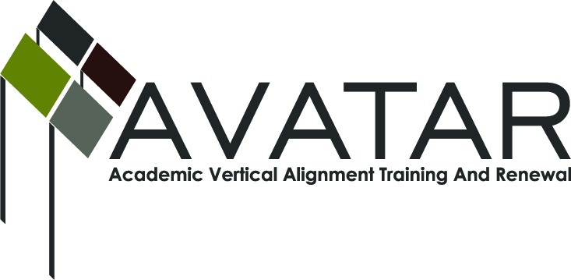
AVATAR Partnership Region: 2
Meeting/Session Documentation Form

Form should be completed after each meeting and given to the Regional AVATAR Coordinator/Facilitator
Meeting: | AVATAR Team Meeting
Meeting Purpose: | Review data, assessments, standards; develop action plan
Date: | October 17, 2012 | Start Time: | 7:30 a.m. | End Time: | 9:00 a.m.
Meeting Coordinator/ Facilitator: | Janet M. Cunningham | Location: |  | Northwest Center for Advanced Studies
Meeting Recorder: | Janet M. Cunningham | Meeting Timekeeper:

Time | Topic | Format | Discussion Leader | Desired Outcome
7:30 a.m. | Welcome  Data presentation and discussion | Presentation | Janet Cunningham
7:50 a.m. | Review assessments: TAKS, THEA, Accuplacer. Discuss similarities/differences | W, D | Janet Cunningham
8:10 a.m. | Review College and Career Readiness standards | P, D, W  O-classroom visit | Entire team
8:30 a.m. | Discuss Action Plan
Agenda Format Key: P = Presentation, F = Feedback, D = Decision-Making, W = Work Group, O = Other, with explanation

AVATAR Meeting Minutes

Action Item | Person Responsible | Due Date
After reviewing data, the team discussed areas of concern, especially in the area of college readiness. | Janet Cunningham | September 29, 2012
The team looked at the different assessments. Generally, not all college instructors are familiar with the Texas Assessment of Knowledge and Skills (TAKS) and high school teachers are not familiar with the THEA or Accuplacer. The high school teachers felt the TAKS was a more rigorous test than the THEA or Accuplacer, but overall the instructors agreed that passing one of these assessments would not ensure success in College Algebra. Team members will review assessment in greater depth. | Team members | October 17, 2012
High school teachers explained that the College and Career Readiness Standards are imbedded in the skills they are required to teach. The CCRS are broad objectives, where as the Texas Essential Knowledge and Skills (TEKS) are more specific. New standards will be in place soon. A copy of the CCRS were given to postsecondary instructors for review. | Paul Johnson  Dr. Fay Bruun | October 17, 2012
The team worked together to develop an action plan for the year. Janet will take the ideas provided and put them in the AVATAR Action Plan Form. | Janet Cunningham | October 30, 2012
Notes

Meeting Participant List

Name | Title | Organization/Institution
Dr. Melana Silva | P-12 Math/Science Teacher | Calallen ISD
Sandra Rippstein | Secondary Mathematics Teacher | Calallen ISD
Paul Johnson | Math Instructor | Del Mar College
Dr. Faye Bruun | Assistant Professor, Department of Curriculum and Instruction | Texas A&M University Corpus Christi
Melissa Morin | Research, Planning, and Initiatives Consultant | Education Service Center, Region 2
Dr. Janet M. Cunningham | Executive Director | Coastal Bend Partners for College and Career Readiness (P-16 Council)

