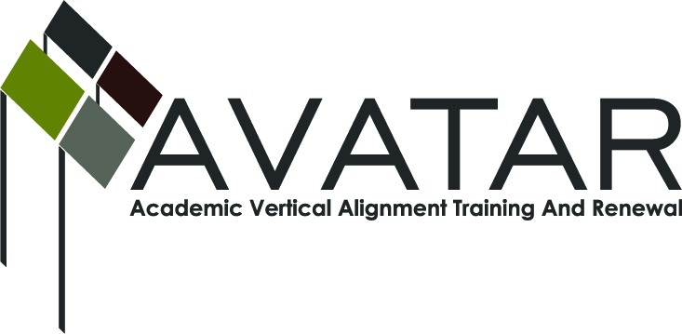
AVATAR Partnership Region: 2
Meeting/Session Documentation Form

Form should be completed after each meeting and given to the Regional AVATAR Coordinator/Facilitator
Meeting: | AVATAR Team Meeting
Meeting Purpose: | Understand critical differences between secondary and post-secondary mathematics instruction
Date: | November 19, 2012 | Start Time: | 7:30 a.m. | End Time: | 9:20 a.m.
Meeting Coordinator/ Facilitator: | Janet M. Cunningham | Location: |  | Northwest Center for Advanced Studies
Meeting Recorder: | Janet M. Cunningham | Meeting Timekeeper:

Time | Topic | Format | Discussion Leader | Desired Outcome
7:30 a.m. | Welcome  Review of action plan | Discussion | Janet Cunningham | Clear understanding of task
7:50 a.m. | Review “Side-by-Side” – Critical Conversations | Presentation/  Discussion | Janet Cunningham | Discussion of system differences
8:20 a.m. | Review and compare CCRS/TEKS Mathematics/College Algebra Course Syllabus | Discussion | Entire team | Understanding of requirements for each level
8:45 a.m. | Discuss Mathematics Symposium  Discuss next meeting | Decision Making | Entire team | Determine date, time, topics
Agenda Format Key: P = Presentation, F = Feedback, D = Decision-Making, W = Work Group, O = Other, with explanation

AVATAR Meeting Minutes

Action Item | Person Responsible | Due Date
The team reviewed the action plan as a work in progress. The team noted that some dates may need to be changed. | Janet Cunningham | December 18, 2012
The team reviewed the handout “Critical Conversations” and noted that in secondary there are lots of support services and students are required to attend in most cases. While there are systems of support available in post-secondary, students must access these on their own. Another major difference is that in secondary, the curriculum is very specific, as well as the assessments, and all teachers are expected to follow the same curriculum give the same tests. Post-secondary instructors have a great deal of flexibility and even standards differ from one institution to another. This is a major concern because it is difficult to prepare students for post-secondary when there is not a clear understanding of what is required at the next level. Members of the team also expressed concerns about the following: inexperienced instructors teaching Developmental Education classes without support and supervision; calculator usage; sequence of math courses; seniors who complete requirements early and do not have a math class in their senior year; limited options for the 4th year of high school math; and issues related to Math Models. After reviewing the CCRS, Math TEKS, and College Algebra Syllabus, concerns were raised about the awareness of the CCRS among college instructors. It was noted that while the TEKS provide a good foundation to prepare students for college algebra, there is so much to cover that often the TEKS are not covered to the depth necessary. These topics may become discussion items for the math symposium. | Janet Cunningham | December 18, 2012
The math symposium was discussed. The goal is to create a shared vision among secondary and post-secondary mathematics teachers, department leaders and instructional staff. The team is looking at a date of March 19 or 21. The event will start at 12:00 with lunch and a guest speaker. There will be 4 breakout sessions from 1:00-1:40; 1:45-2:25; 2:30-3:10, and 3:15-4:00. Topics will include 1) TEKS/CCRS, 2) Assessments, 3) Developmental Education, and 4) Calculators/Inspire. Janet will work on confirming the date/place. | Janet Cunningham | March 21, 2013
The team agreed to meet on Tuesday, December 18 at 1:00. Janet will work on lining up presentations of what others in the area are doing in the area of mathematics. | Janet Cunningham | December 18, 2012

Meeting Participant List

Name | Title | Organization/Institution
Dr. Melana Silva | P-12 Math/Science Teacher | Calallen ISD
Sandra Rippstein | Secondary Mathematics Teacher | Calallen ISD
Paul Johnson | Math Instructor | Del Mar College
Dr. Faye Bruun | Assistant Professor, Department of Curriculum and Instruction | Texas A&M University Corpus Christi
Dr. Janet M. Cunningham | Executive Director | Coastal Bend Partners for College and Career Readiness (P-16 Council)

