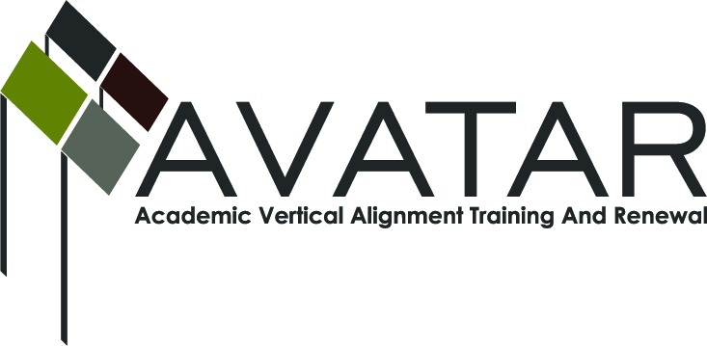
AVATAR Partnership Region: 2
Meeting/Session Documentation Form

Form should be completed after each meeting and given to the Regional AVATAR Coordinator/Facilitator
Meeting: | AVATAR Team Meeting
Meeting Purpose: | Discuss Math Symposium and follow up plan
Date: | March 20, 2013 | Start Time: | 7:30 a.m. | End Time: | 8:30 a.m.
Meeting Coordinator/ Facilitator: | Janet M. Cunningham | Location: |  | Northwest Center for Advanced Studies
Meeting Recorder: | Janet M. Cunningham | Meeting Timekeeper: |  | Connie J. Nowell

Time | Topic | Format | Discussion Leader | Desired Outcome
7:30 a.m. | Welcome | Discussion | Janet Cunningham
7:40 a.m. | Mathematics Symposium | Discussion | Janet Cunningham | Review symposium details
8:00 a.m. | “Next Steps” | Discussion | Janet Cunningham | Set plans for follow up
8:3 0 a.m. | Next Meeting | Discussion | Janet Cunningham | Set date
Agenda Format Key: P = Presentation, F = Feedback, D = Decision-Making, W = Work Group, O = Other, with explanation
AVATAR Meeting Minutes
Action Item | Person Responsible | Due Date
The team discussed the Math Symposium:  Registration number – Melissa Morin will check on number of registrants – name, position, place of business. Everyone needs to send follow-up invitations. Name tags will have some indication of where participants will sit.  Pre-conference session: 10:00 a.m.-noon in same room – Let attendees know about pre-conference with Paula Talley, representative of Dana Center.  Schedule – was reviewed and presenters discussed  Lunch – 25 have been ordered; will keep close eye on registrants so this number can be amended if needed  Audience – College advisors, high school counselors, superintendents need to be informed. Debra Jones and Lynn Dodge from ESC should be notified  Publicity – Two sentence explanation of each session should be sent to Melissa Morin who will produce a press release  Registration Desk – Sign in sheet; name tags; assign tables  Staffing – All will attend  Evaluation – will be emailed to attendees immediately following symposium; certificates will be issued through ESC. A certificate for the pre-conference will need to be generated and mailed.  Continue Work? - There is hope for next year’s symposium; no definite date has been set. Need to invite other participants; can be selected from attendees. TAMU-CC and Del Mar will continue to participate, as well as Calallen. | Melissa Morin  All Members  Janet Cunningham  Janet Cunningham  Melissa Morin  Melissa Morin  ESC2; Janet Cunningham  Janet Cunningham | March 25, 2013  March 21, 2013  March 25, 2013  March 21, 2013  March 21, 2013  March 27, 2013  March 27, 2013
“Next Steps” – discussion on what should happen next and when. At end of symposium, invite attendees to attend informal discussion on April 17 from 1:30 – 3:30 at ESC (after P-16 meeting); publicize the math/science conference. Use “Me By The Sea” (June 14, TAMU-CC) for dissemination of information of CCRS. | Janet Cunningham
The team agreed to meet on Thursday, April 11, 7:30 a.m. to follow up

Meeting Participant List

Name | Title | Organization/Institution
Dr. Melana Silva | Curriculum Specialist | Calallen ISD
Paul Johnson | Math Instructor | Del Mar College
Dr. Faye Bruun | Assistant Professor, Department of Curriculum and Instruction | Texas A&M University Corpus Christi
Sandra Rippstein | Secondary Math Teacher | Calallen High School
Melissa Morin | Consultant | ESC-2
Dr. Janet M. Cunningham | Executive Director | Coastal Bend Partners for College and Career Readiness (P-16 Council)

