Hello!

FAFSA/TASFA season is underway and we want to make sure families know where they can receive help completing their financial aid applications. Flyers and postcards for students and parents can be downloaded from: http://youcanaffordcollege.org/counselor-and-site-lead-resources/.
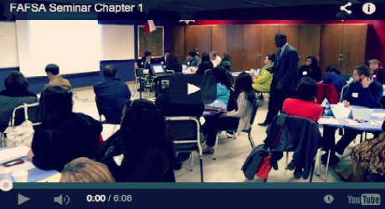 | Counselor and Site Lead Resources - Youcanaffordcollege.org  youcanaffordcollege.org  Last year, about 6,000 Dallas County seniors each left thousands of dollars in grant aid on the table by not filing a FAFSA . Don’t let that be you!

Can you post one of these today?

Twitter:
- Worried how to pay for college? File your #FAFSA or #TASFA! Get free expert help @ Dallas workshops: goo.gl/ExgwHs #FirstFAFSA
- Headed to college next year? Don’t miss out on $$! Attend a free FAFSA/TASFA workshop for help: goo.gl/ExgwHs #FirstFAFSA
- Last year thousands Dallas seniors left over $30 million on the table by not filing a #FAFSA. Don’t let that be you! goo.gl/ExgwHs
Facebook (image attached):
- Sample #1: Preparing for College? Free, one-on-one help completing state and federal financial aid applications (FAFSA/TASFA) will be provided by financial aid staff and trained volunteers at five Dallas-area workshops. Families are welcome to drop in anytime between 9am-2pm. These workshops are open to anyone pursuing a two-year or four-year college education during the 2016-17 school year. Guests will have the chance to win a laptop, bike, gift cards, or residence hall essentials!
- Sample #2: Attention high school seniors, current college students, and GED completers! College can be more affordable than you think. Take advantage of the opportunity to file your financial aid application at a free workshop near you! Visit goo.gl/ExgwHs for more information and to RSVP. #FirstFAFSA #YouCanAffordCollege.
- Sample #3: There's more to college financial aid than student loans. Grants, scholarships, and work-study awards can all help you afford an education you might have thought was out of reach. Need help with the financial aid applications? Visit goo.gl/ExgwHs for more information and to RSVP for a Dallas workshop.
E-mail/Newsletter:
Subject: Financial Aid Help for College Bound Students!

Preparing for College? Free, one-on-one help completing state and federal financial aid applications (FAFSA/TASFA) will be provided by financial aid staff and trained volunteers at five Dallas-area workshops. Families are welcome to drop in anytime between 9am-2pm. These workshops are open to anyone pursuing a two-year or four-year college education during the 2016-17 school year.

Already started your application? Come by to pick up scholarship information or to receive help finishing the verification process. Volunteers will also be available to help you understand how to read a financial aid award letter.
Guests attending one of the community workshops below will have the chance to win a laptop, bike, gift cards, or residence hall essentials! To register visit www.YouCanAffordCollege.org.

Feb 20 | 9a-2p | Lake Highlands HS and Molina HS
Feb 27 | 9a-2p | Bryan Adams HS and WiNGS
Mar 5 | 9a-2p | Carter HS

Follow Us!
Facebook: www.facebook.com/Commit2Dallas
Twitter: @Commit2Dallas
Instagram: @YouCanAffordCollege

Sarah Jensen
Deputy Director, College Access & Success
214.451.0556 | Sarah.Jensen@commit2dallas.org
www.YouCanAffordCollege.org

