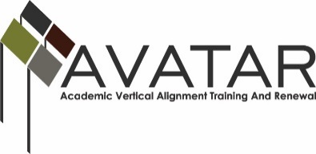
AVATAR Partnership Region: ______ESC 5________
Meeting/Session Documentation Form

Form should be completed after each meeting and given to the Regional AVATAR Coordinator/Facilitator
Meeting: | Vertical Alignment Team Meeting 3
Meeting Purpose: | Decision Making for Vertical Alignment Team Update
Date: | April 30, 2015 | Start Time: | 1:30pm | End Time: | 2:00pm
Meeting Coordinator/ Facilitator: | Maris Peno | Location: |  | Web-Based – Used Go to Webinar
Meeting Recorder: | Go to Webinar Software | Meeting Timekeeper: |  | Go to Webinar Software

Time | Topic | Format | Discussion Leader | Desired Outcome
1:30-2:00 | AVATAR PowerPoint | P | Maris Peno | Updates and decision making for the VAT
Agenda Format Key: P = Presentation, F = Feedback, D = Decision-Making, W = Work Group, O = Other, with explanation

AVATAR Meeting Minutes

Action Item | Person Responsible | Due Date
Participants will vote for their choice presented in the presentation | Attendees | May 7, 2015
Notes
Web-based update

Decisions need to be made about the method for course completion for CPC. The team was divided between a college developed course and the TSI.
Meeting Participant List

Name | Title | Organization/Institution
See separate sign in sheet

