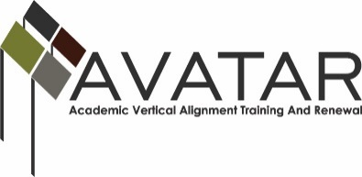
AVATAR Partnership Region: ______ESC 5________
Meeting/Session Documentation Form

Form should be completed after each meeting and given to the Regional AVATAR Coordinator/Facilitator
Meeting: | Vertical Alignment Team Meeting 2
Meeting Purpose: | Review objectives for project and regional data
Date: | February 26, 2015 | Start Time: | 1:30pm | End Time: | 3:30pm
Meeting Coordinator/ Facilitator: | Maris Peno | Location: |  | Region 5 Education Service Center- Beaumont, TX
Meeting Recorder: | Maris Peno | Meeting Timekeeper: |  | Maris Peno

Time | Topic | Format | Discussion Leader | Desired Outcome
1:30-2:30 | AVATAR Data PowerPoint | P | Maris Peno | Introduce the AVATAR Process and the CPC Project
2:30-2:45 | Break
2:45-3:30 | Group Discussion on Current Practices and Q&A | F, D | Maris Peno | District and College participants share their current practices and troubleshoot
Agenda Format Key: P = Presentation, F = Feedback, D = Decision-Making, W = Work Group, O = Other, with explanation

AVATAR Meeting Minutes

Action Item | Person Responsible | Due Date
Communicate your schedule to the facilitator | Attendees | March 5, 2015
Facilitator will schedule individual subject team meetings | Maris Peno | March 2015-April 2015
Subject Teams will research current practices for college prep courses and bring information to first subject CPC meeting | Attendees | April 7, 2015
Notes
Peno presented PowerPoint for second meeting.

No participants from the first AVATAR Meeting attended. Therefore, we started over with new participants.
Facilitator created a voice over powerpoint to send to new participants so they would understand the purpose for the projects.
Meeting Participant List

Name | Title | Organization/Institution
See separate sign in sheet

