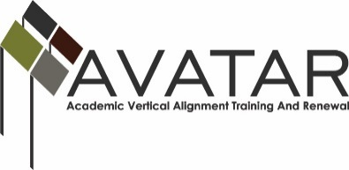
AVATAR Partnership Region: ______ESC 5________
Meeting/Session Documentation Form

Form should be completed after each meeting and given to the Regional AVATAR Coordinator/Facilitator
Meeting: | Vertical Alignment Team Meeting 1
Meeting Purpose: | Introduction to the AVATAR process and CPC project
Date: | January 22, 2015 | Start Time: | 9:00 am | End Time: | 11:00 am
Meeting Coordinator/ Facilitator: | Maris Peno | Location: |  | Region 5 Education Service Center- Beaumont, TX
Meeting Recorder: | Maris Peno | Meeting Timekeeper: |  | Maris Peno

Time | Topic | Format | Discussion Leader | Desired Outcome
9:00-10:00 | AVATAR Process PowerPoint | P | Maris Peno | Introduce the AVATAR Process and the CPC Project
10:00-10:15 | Break
10:15-11:00 | Group Discussion on Current Practices and Q&A | F, D | Maris Peno | District and College participants will decided if they would like to join our VAT.
Agenda Format Key: P = Presentation, F = Feedback, D = Decision-Making, W = Work Group, O = Other, with explanation

AVATAR Meeting Minutes

Action Item | Person Responsible | Due Date
Reply to Faciliator on status of district/college participation | Attendees | Feb 25, 2015
Notes
Peno presented PowerPoint for first meeting.

4 attendees from various districts/colleges- Lots of questions about CPC and the need to have them implemented in a district
Meeting Participant List

Name | Title | Organization/Institution
See separate sign in sheet

