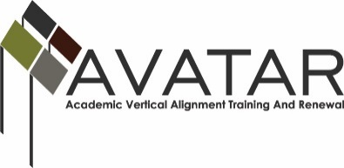
AVATAR Partnership Region: ______ESC 5________
Meeting/Session Documentation Form

Form should be completed after each meeting and given to the Regional AVATAR Coordinator/Facilitator
Meeting: | Vertical Alignment Team Meeting 4
Meeting Purpose: | Revise and Edit final MOU and Syllabi
Date: | May 19, 2015 | Start Time: | 1:30pm | End Time: | 3:30pm
Meeting Coordinator/ Facilitator: | Maris Peno | Location: |  | Region 5 ESC – Beaumont, TX
Meeting Recorder: |  | Meeting Timekeeper:

Time | Topic | Format | Discussion Leader | Desired Outcome
1:30-2:30 | AVATAR PowerPoint | P | Maris Peno | Presentation of the final MOU and Syllabi
2:30-3:20 | Revise and Edit | F, D, W | Maris Peno | Revise and Edit the final MOU AND Syllabi
Agenda Format Key: P = Presentation, F = Feedback, D = Decision-Making, W = Work Group, O = Other, with explanation

AVATAR Meeting Minutes

Action Item | Person Responsible | Due Date
Participants will submit proposed updates to facilitator | Participants and Maris Peno | May 28, 2015
Facilitator will compile list of changes and email to group | Maris Peno | May 28, 2015
Notes
Revisions and suggestions were made after this meeting.

Then only change which met opposition was to leave the Indemnification section out of the contract. After much discussion, all entities decided to leave it out.
Meeting Participant List

Name | Title | Organization/Institution
See separate sign in sheet

